School Of Mechanical & Manufacturing Engineering, NUST

Department of Mechanical Engineering

CS-114 - Fundamental of Programing

Lab Manual # 05

**Course Instructor:** Dr Khwaja Fahad Iqbal

**Lab Instructor:** Muhammad Affan

**Student Name: ZORAIZ ABBAS**

**CMS ID: 454752**

**DATE:**

**27 OCT 2K23**

**TASK 1:**

1. Convert the following while loop to a do-while loop:

int x = 1; while (x > 0) { cout << "enter a number: "; cin >> x; }

**ANSWER:**

#include<iostream>

using namespace std;

int main(){

int x=1;

do{

cout<<"enter a number :"<<endl;

cin>>x;

}

while(x>0);

return 0;

}

**Result:**

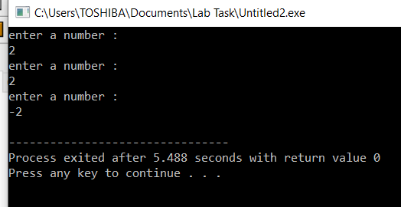

**TASK 2:**

Use a do while loop to make a simple calculator for two numbers. Insert buttons for it to ask again and for termination.

**ANSWER:**

#include <iostream>

#include<math.h>

using namespace std;

int main()

{ int y;

int a;

int b;

char op;

int ans;

do{

cout<<"Enter two numbers : "<<endl;

cin>>a;

cin>>b;

cout<<"enter the opreation *,+,-,/,%, ^:"<<endl;

cin>>op;

switch(op){

case'+':

ans=a+b;

break;

case'-':

ans=a-b;

break;

case'/':

ans=a/b;

break;

case'*':

ans=a*b;

break;

case'^':

ans=pow(a,b);

break;

case'%':

ans=a%b;

break;

default:

cout<<"enter valid input"<<endl;}

cout<<ans<<endl;

cout<<"Enter 1 to repeat function and 0 to terminate "<<endl;

cin>>y;

}

while(y==1);

return 0;

}

**Result:**

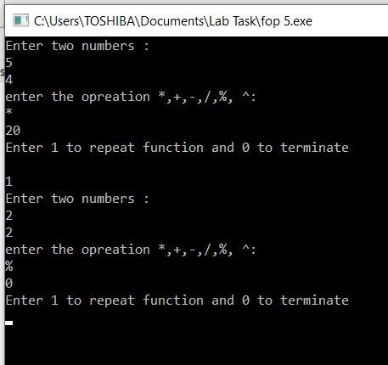 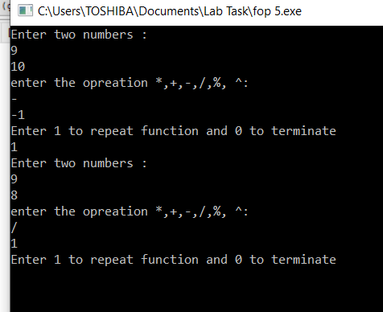

**Task 3:**

Write programs with while or do while loops that compute:

**A**.The sum of all even numbers between 2 and 100 (inclusive).

**Answer:**

#include<iostream>

using namespace std ;

int main(){

int num=2;

int sum=0;

while(num<=100){

if(num%2==0){

sum=sum+num;

}

num++;}

cout<<sum;

return 0;

}

**Result:**

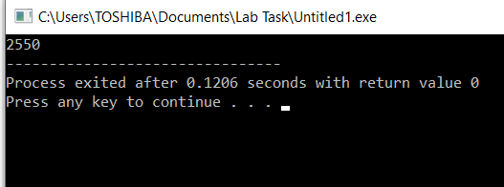

**B.** The sum of all squares between 1 and 100 (inclusive).

**Answer:**

#include<iostream>

#include<math.h>

using namespace std;

int main(){

int x=1,sum=0;

while(x<=100){

sum=sum+pow(x,2);

x++;

}

cout<<"the sum of all squres between 0 and 100: "<<sum<<endl;

return 0;

}

**Result:**

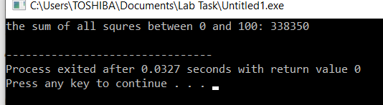

**Task 4:**

Write programs with while or do while loops that compute:

**A**.All powers of 2 from 2^0 up to 2^20 .

**Answer:**

#include<iostream>

#include<math.h>

using namespace std;

int main(){

int num=0;

while(num<=20){

cout<<pow(2,num);

num++;

}

return 0;

}

**Result:**

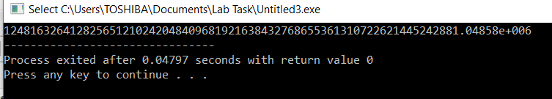

**B.** The sum of all odd numbers between a and b (inclusive), where a and b are inputs.

**Answer:**

#include<iostream>

using namespace std;

int main(){

int a,b,sum=0;

cout<<"Enter first number:"<<endl;

cin>>a;

cout<<"Enter second number:"<<endl;

cin>>b;

while(a<b){

if(a%2==1){

sum=sum+a;

}

a++;

} cout<<"The sum of odd numbers between a and b is: "<<sum<<endl;

return 0;

}

**Result:**

